Question Bank – Computer Graphics
Unit 1

Basics of Computer Graphics
- Define computer graphics.
- Define terms: Image, Object, Pixel, Resolution.
- List and explain applications of computer graphics.
Display Devices
- Explain CRT with neat diagram.
- Explain Raster Scan display
- Explain Random Scan Display
- Differentiate between Random scan and Raster Scan.
- Describe working principal of flat panel display.
- Describe the working principal of LED display.
- Describe working principal of LCD display.
- Describe working principal of plasma display.
- Describe the working of LCD.

Graphics functions and standards
- List three basic primitive functions and explain any one of it.
- Explain text mode graphics function used to display the string 'Hello' at some specified location in specific color with its syntax.
- How to initialize graphics mode of your display system?
- Write a C code to display a single pixel on screen.
- Write a C program to draw rectangle and circle on screen.
- Write a C program to draw a triangle using line commands on screen.
- Describe the command used to color a given shape with its syntax.
- Write a C code to draw a polygon and then fill it with yellow color.
- What is the need of closegraph() function in graphics program?
- Explain any three graphics standards.
- What is the need for coordinate systems ? Describe various coordinate systems
- Write a short note on Cartesian coordinate systems.
- Write a short note on Polar coordinate systems
- Describe various graphics functions.
Advanced Topic
- Discuss virtual reality system.
- Describe various components of virtual reality
- List and describe the types of VR systems.
- List and discuss the types of Augmented Reality systems
- Describe applications of virtual reality and augmented reality.
Unit 2
Basic Concepts in Line Drawing
- Define the following terms: Point, Rasterization.
- How to draw a line using slope-intercept formula?
- State the characteristics of an ideal line.
- Enlist three methods of line representation.
- What do you mean by scan conversion of line?
Digital Differential Analyzer (DDA) Line Drawing Algorithm
- Explain DDA line drawing algorithm.
- Enlist merits and demerits of DDA line drawing algorithm.
- Mention the steps to draw line with |m| > 1 using DDA line drawing algorithm.
- Write an algorithm for DDA line drawing algorithm.
- Calculate the pixel coordinates of line AB using DDA algorithm, where A = (0,0) and B = (6,8).
- Draw a line from A(2,3) to B(7,9) using DDA line drawing algorithm.
- Write C code to scan convert the line using DDA algorithm.
Bresenham’s Line Drawing Algorithm
- Explain Bresenham’s line drawing algorithm. Derive decision parameters.
- Mention the steps to draw line using Bresenham’s method.
- State advantages and disadvantages of Bresenham’s line drawing approach.
- Write a function Bresenham Line(x1, y1, x2, y2, type) so it draws a line with specified type. If type = 0, solid line; type = 1, dashed line; and type = 2, dotted line.
- Calculate the pixel coordinates of line PQ using Bresenham’s algorithm where P = (20,20) and Q = (10,12).
- Write an algorithm for Bresenham’s line drawing algorithm.
- Differentiate DDA vs. Bresenham’s line drawing algorithm.
- Write C code to scan convert the line using Bresenham’s algorithm.
Circle Generation Algorithms
- Derive equations of decision parameter for Bresenham’s circle drawing algorithm.
- Write the steps for Bresenham’s circle generation algorithm.
- Write an algorithm for Bresenham’s circle drawing algorithm.
- Plot a circle using Bresenham’s algorithm for r = 5 and center at (0,0).
- Write a program to scan convert the circle using incremental approach.
- Write a program to scan convert the circle using Bresenham’s circle generation algorithm.
- Write the steps for Mid Point circle generation algorithm.
- Plot a circle using Mid Point algorithm for r = 10 and center at (0,0).

Polygon Filling Algorithms
- What is polygon? Explain various types of polygon.
- Explain inside-outside test to check the membership of pixel with respect to given polygon.
- Describe odd-even method with suitable example.
- Explain winding number rule method.
- Explain boundary fill Algorithm
- Write a C code for boundary fill Algorithm
- Explain flood fill Algorithm.
- Write a C code for flood fill Algorithm.
- Write an algorithm for flood fill.
- State the advantages and disadvantages of seed fill algorithms.
- Explain scan line polygon filling algorithm
- Differentiate Seed fill and scan line algorithm

Unit 3
- Define transformation
- List out basic transformation techniques
- Describe coordinate transformation
- Describe 2D transformation. Derive transformation matrix for the same.
- Translate a triangle with coordinate A(2,2), B(6,2) and C(4,4) with translation vector [4, 7]^{T}

Unit 4
Windowing & Clipping
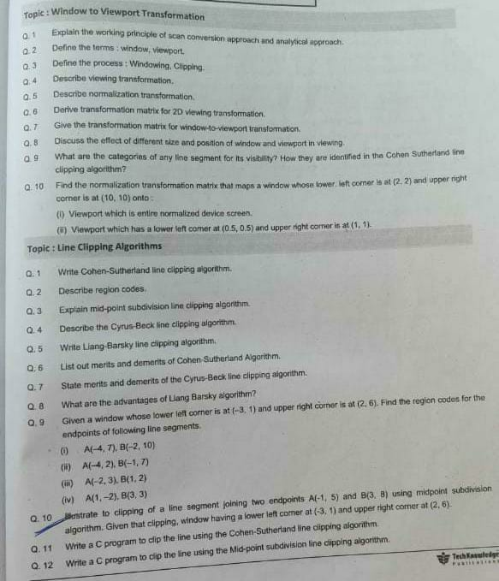

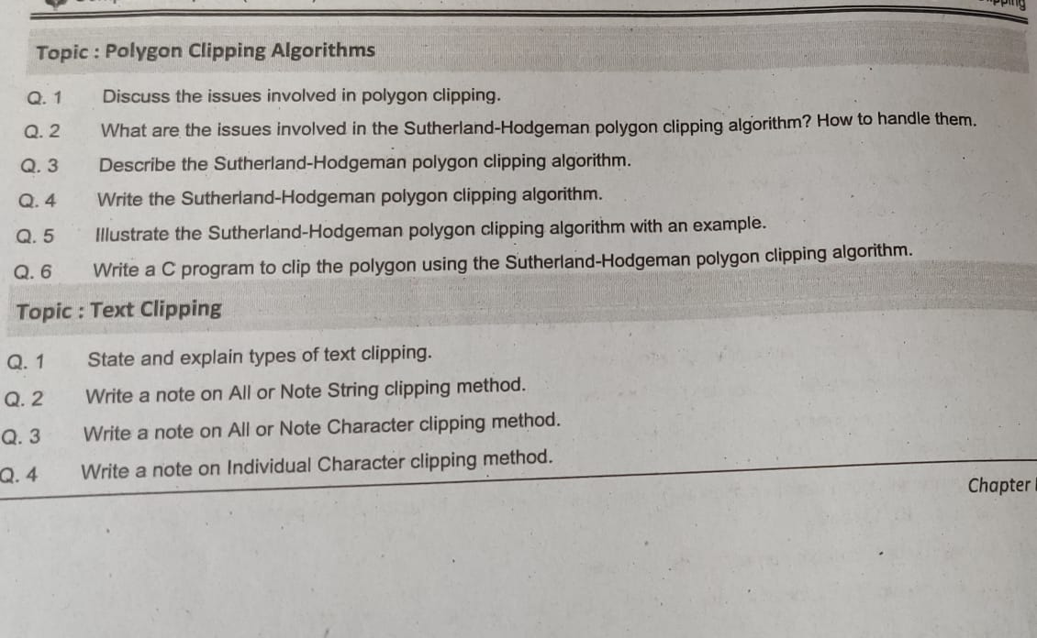

Unit 5
Curves and Fractals

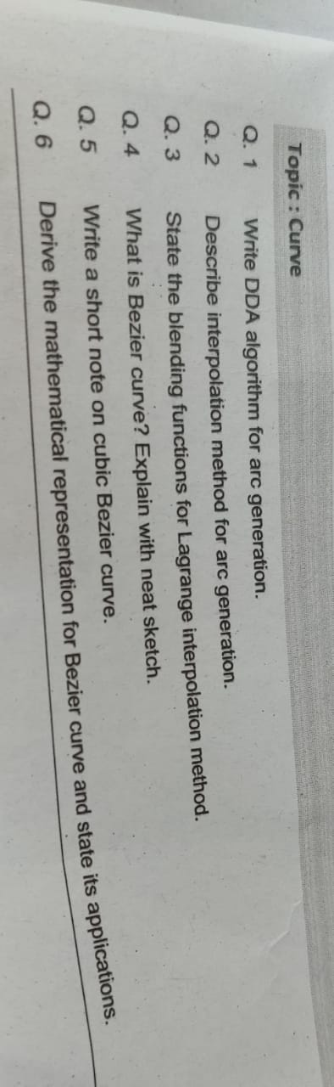

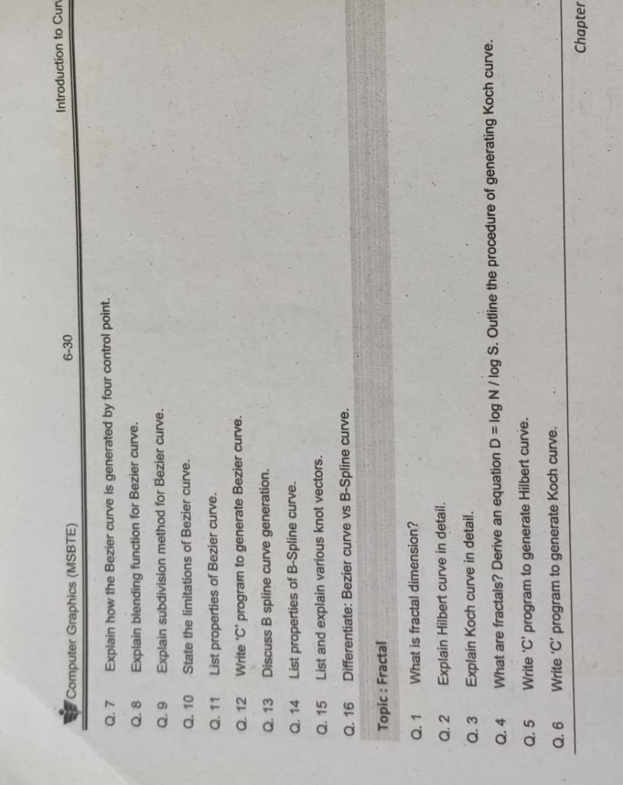
Unit 6
Interactive Graphics
Topic: Need for graphics standards, Advantages of Graphics standards, Hazards of Graphics standards.
- What is the main purpose of having graphics standards in computer graphics?
- Mention any two advantages of using graphics standards.
- Define graphics standards with an example.
- Give two hazards of using graphics standards.
- Why is interoperability important in graphics systems?
- Explain the need for graphics standards in computer graphics.
- Discuss the major advantages of using standardized graphics APIs.
- What are the potential hazards or limitations of graphics standards? Explain with examples.
- Compare the benefits and drawbacks of using graphics standards in application development.
- How do graphics standards influence cross-platform graphics development?
Topic: Graphical user interface: Introduction, Example
- What is a Graphical User Interface (GUI)?
- List two key features of a GUI.
- Give one example of a GUI-based operating system.
- How does a GUI differ from a Command Line Interface (CLI)?
- What input devices are commonly used to interact with a GUI?
- Why are GUIs considered more user-friendly than command-line interfaces?
- Name any two components commonly found in a GUI.
- Describe the role of icons and buttons in a GUI.
- Explain how a mobile app GUI differs from a desktop GUI.
- What does WYSIWYG stand for, and how is it related to GUIs?
- Explain how the GUI of Microsoft Word helps users format documents.
- Describe a situation where using a GUI is more beneficial than using a CLI.
- How can GUIs improve accessibility for users with disabilities?
- Mention any software or tool used to design or create GUIs.
- What are the challenges in designing a good GUI?
Topic: Open GL: What is Open GL, How OpenGL works
- What does OpenGL stand for?
- What is the primary purpose of OpenGL?
- Is OpenGL a hardware or software? Explain.
- Who originally developed OpenGL?
- Name one application or software that uses OpenGL.
- Explain how OpenGL helps in rendering graphics.
- What is meant by an OpenGL context?
- What are shaders in OpenGL, and what is their role?
- What types of transformations can be applied to objects in OpenGL?
- Why is OpenGL considered cross-platform?
- Describe the general workflow of how OpenGL renders a 3D object.
- How does OpenGL communicate with the GPU?
- What is the difference between vertex and fragment shaders in OpenGL?
- Explain how OpenGL can be used in a game engine.
- How does OpenGL handle 2D and 3D graphics differently?

ANS OF UNIT 1

Basics of Computer Graphics

1. Define Computer Graphics.
Computer Graphics refers to the creation, manipulation, and representation of visual images using computers. It involves techniques for rendering 2D and 3D images and animations.

2. Define terms:

i) Image:
An image is a visual representation of an object stored in a digital format.

ii) Object:
An object is a geometric entity (such as a circle, rectangle, or 3D model) used in graphics.

iii) Pixel:
A pixel (picture element) is the smallest unit of a digital image, represented as a tiny dot on the screen.

iv) Resolution:
Resolution refers to the number of pixels in an image or display. It is expressed as width × height, e.g., 1920 × 1080 pixels.

3. List and explain applications of computer graphics.
Computer graphics is used in multiple fields:
- Entertainment – Used in movies, video games, and animations.
- CAD (Computer-Aided Design) – Used for architectural modeling, mechanical parts, and circuit design.
- Medical Imaging – CT scans, MRI visualizations.
- Simulation & Virtual Reality – Used in military, flight simulation, and training.
- Data Visualization – Graphs, pie charts, and scientific visual representation.

Display Devices

1. Explain CRT with a neat diagram.
Cathode Ray Tube (CRT) works by:
- Emitting an electron beam onto a phosphor-coated screen.
- The phosphor glows, creating an image.
- Horizontal and vertical deflection control positioning.
(A diagram would be required for a complete answer.)

2. Explain Raster Scan Display.
- Pixels are arranged in a grid.
- Electron beam scans from left to right, top to bottom.
- Uses frame buffers to store image data.

3. Explain Random Scan Display.
- Draws images using mathematical equations.
- Uses line-drawing algorithms instead of scanning pixels.
- Efficient for vector graphics.

4. Differentiate between Random Scan and Raster Scan.
Feature | Random Scan | Raster Scan
Type | Vector Graphics | Raster Graphics
Image Formation | Draws lines directly | Scans pixels row-wise
Memory | Less memory required | Uses frame buffer
Speed | Faster for line drawings | Better for complex images

5. Describe the working principle of flat panel display.
Flat-panel displays use liquid crystals, organic LEDs (OLEDs), or plasma technology to produce images.

6. Describe the working principle of LED Display.
- Uses light-emitting diodes (LEDs).
- Faster refresh rate and brighter display.
- Energy efficient compared to CRTs.

7. Describe the working principle of LCD Display.
- Uses Liquid Crystal Molecules.
- A backlight shines through pixels to create an image.
- Thin, lightweight, and energy-efficient.

8. Describe the working principle of Plasma Display.
- Uses tiny gas-filled cells (plasma).
- When charged, they emit light to form an image.
- Better contrast and color accuracy than LCDs.

9. Describe the working of LCD.
- Uses polarized light and liquid crystals.
- When electricity is applied, it changes the alignment of crystals.
- Controlled blocking or passing of light creates an image.

Graphics Functions and Standards

1. List three basic primitive functions and explain any one of them.
Basic primitives:
- Line drawing (line(x1, y1, x2, y2);)
- Circle drawing (circle(x, y, radius);)
- Rectangle drawing (rectangle(x1, y1, x2, y2);)

2. Explain text mode graphics function for displaying ‘Hello’.
outtextxy(x, y, "Hello");
- x, y → Coordinates.
- "Hello" → Text to display.

3. How to initialize graphics mode?
int gdriver = DETECT, gmode;
initgraph(&gdriver, &gmode, "C:\\TURBOC3\\BGI");

4. C program to display a single pixel.
#include <graphics.h>
int main()
{
int gd = DETECT, gm;
initgraph(&gd, &gm, "");
putpixel(100, 100, WHITE);
getch();
closegraph();
return 0;
}

5. C program to draw a rectangle and a circle.
#include <graphics.h>
int main() {
int gd = DETECT, gm;
initgraph(&gd, &gm, "");
rectangle(100, 100, 200, 200);
circle(150, 150, 50);
getch();
closegraph();
return 0;
}

6. C program to draw a triangle using line commands.
#include <graphics.h>
int main() {
int gd = DETECT, gm;
initgraph(&gd, &gm, "");
line(100, 100, 200, 200);
line(200, 200, 300, 100);
line(300, 100, 100, 100);
getch();
closegraph();
return 0;
}

7. Describe the command used to color a shape.
setfillstyle(SOLID_FILL, RED);
floodfill(x, y, boundary_color);
- floodfill(x, y, boundary_color); → Fills closed shapes.

8. C program to draw and fill a polygon.
#include <graphics.h>
int main() {
int gd = DETECT, gm;
int points[] = {100, 100, 200, 200, 300, 100, 100, 100};
initgraph(&gd, &gm, "");
drawpoly(4, points);
setfillstyle(SOLID_FILL, YELLOW);
floodfill(150, 150, WHITE);
getch();
closegraph();
return 0;
}

9. Need for closegraph() function.
- Closes graphics mode and frees memory.
- Prevents errors in other programs.

10. Explain three graphics standards.
- OpenGL – Used for 3D rendegring.
- DirectX – Microsoft’s graphics standard.
- SVG (Scalable Vector Graphics) – XML-based vector format.

Advanced Topics

1. Discuss Virtual Reality System.
- Simulates real-world environments.
- Uses 3D graphics, sensors, and interaction devices.

2. Components of Virtual Reality
- Hardware – VR headset, motion tracking.
- Software – VR engines (Unreal Engine, Unity).
- Interaction Devices – Gloves, controllers.

3. Types of VR systems.
- Non-Immersive VR – Computer-based simulations.
- Semi-Immersive VR – 3D projection screens.
- Fully Immersive VR – VR headsets like Oculus, HTC Vive.

4. Types of Augmented Reality (AR).
- Marker-based AR – Uses QR codes or images.
- Markerless AR – Uses GPS and sensors.
- Projection-based AR – Holograms.
- Superimposition AR – Overlays digital objects.

5. Applications of VR and AR in Computer Graphics.
- Gaming (VR headsets, AR mobile games)
- Medical Training (VR Surgery Simulations)
- Education (AR books, VR classrooms)

1. Define the following terms:

📍 Point:
- A point is the smallest unit of a graphic image in a computer graphics system.
- It is represented as a pair of coordinates (x, y) in a 2D space or (x, y, z) in 3D space.

📍 Rasterization:
- Rasterization is the process of converting geometric shapes (lines, circles, polygons, etc.) into pixels on a raster display.
- It is also known as scan conversion.

2. How to draw a line using slope-intercept formula?
The slope-intercept form of a line equation is:
y=mx+cy
Where:
- m = slope of the line (rise/run or Δy/Δx)
- c = y-intercept (where the line crosses the y-axis)

Steps to draw a line using slope-intercept formula:
- Identify two points (x1, y1) and (x2, y2).
- Compute the slope (m):m=y2−y1/ x2−x1
- Start at (x1, y1) and compute new y values for each x increment.
- Plot the points (x, y) on the screen.

3. State the characteristics of an ideal line.
An ideal line should have the following characteristics:
- Continuity: The line should be smooth without breaks.
- Straightness: The line should be geometrically straight.
- Uniform Thickness: The width of the line should be constant.
- Accuracy: The plotted pixels should closely match the true mathematical line.
- No aliasing effects: Should not have jagged edges (staircase effect).
- High Speed: The algorithm should draw the line efficiently.

4. Enlist three methods of line representation.
- Explicit Equation (Slope-Intercept Form):
y=mx+cy
Used when x is independent.
- Implicit Equation (General Form):
Ax+By+C=0
  - Used in computational geometry.
- Parametric Form:
x=x1+t(x2−x1)
  - Used in animation and transformations.

5. What do you mean by scan conversion of a line?
Scan conversion is the process of converting a line’s mathematical representation into a series of pixels on a raster screen.
- It determines which pixels need to be illuminated to represent a continuous line.
- Algorithms such as DDA and Bresenham’s Line Algorithm are used for scan conversion.

📌 Digital Differential Analyzer (DDA) Line Drawing Algorithm

1. Explain DDA line drawing algorithm.
The DDA (Digital Differential Analyzer) Algorithm is used to draw a straight line between two points by incrementing one coordinate at a constant rate.

Steps of DDA Algorithm:
- Calculate Δx and Δy:Δx=x2−x1,Δy=y2−y1\Delta x = x_2 - x_1, \quad \Delta y = y_2 - y_1Δx=x2​−x1​,Δy=y2​−y1​
- Find the number of steps:Steps=max⁡(∣Δx∣,∣Δy∣)\text{Steps} = \max(|\Delta x|, |\Delta y|)Steps=max(∣Δx∣,∣Δy∣)
- Compute increments:Xinc=ΔxSteps,Yinc=ΔyStepsX_{\text{inc}} = \frac{\Delta x}{\text{Steps}}, \quad Y_{\text{inc}} = \frac{\Delta y}{\text{Steps}}Xinc​=StepsΔx​,Yinc​=StepsΔy​
- Start from (x1, y1) and plot pixels until (x2, y2).

2. Merits and Demerits of DDA Algorithm

✅ Merits:
- Simple and easy to implement.
- Faster than using floating-point calculations directly in the equation y=mx+cy = mx + cy=mx+c.
- Works for all types of slopes.

❌ Demerits:
- Uses floating-point arithmetic, which can be slow on older hardware.
- Round-off errors may cause inaccuracy in line drawing.
- More calculations compared to Bresenham’s algorithm.

3. Steps to draw a line with |m| > 1 using DDA Algorithm
If |m| > 1 (steep slope):
- Swap x and y coordinates.
- Compute steps using |Δy| instead of |Δx|.
- Increment y in unit steps and compute corresponding x.

4. Algorithm for DDA Line Drawing Algorithm
Step 1: Input (x1, y1) and (x2, y2)
Step 2: Calculate Δx = x2 - x1 and Δy = y2 - y1
Step 3: Find steps = max(|Δx|, |Δy|)
Step 4: Compute increments:
Xinc = Δx / Steps
Yinc = Δy / Steps
Step 5: Initialize (x, y) = (x1, y1)
Step 6: Repeat for Steps times:
- Plot pixel at (round(x), round(y))
- x = x + Xinc
- y = y + Yinc
Step 7: End

5. Calculate the pixel coordinates of line AB using DDA Algorithm

Given:
A(0,0), B(6,8)Calculate
Δx=6−0=6,Δy=8−0=8
Steps = max(6,8) = 8
- Compute increments
Xinc=6/8=0.75,Yinc=8/8=1.0
Plot Points: | Step | X | Y | Rounded (X, Y) | |------|----|----|----------------| | 0 | 0 | 0 | (0,0) | | 1 | 0.75 | 1 | (1,1) | | 2 | 1.5 | 2 | (2,2) | | 3 | 2.25 | 3 | (2,3) | | 4 | 3.0 | 4 | (3,4) | | 5 | 3.75 | 5 | (4,5) | | 6 | 4.5 | 6 | (5,6) | | 7 | 5.25 | 7 | (5,7) | | 8 | 6.0 | 8 | (6,8) |

6. Draw a line from A(2,3) to B(7,9) using DDA Algorithm
Follow same steps as above.

7. Write C code for DDA Line Drawing Algorithm
c
CopyEdit
#include <graphics.h>
#include <conio.h>
#include <math.h>

void drawLineDDA(int x1, int y1, int x2, int y2) {
int steps;
float Xinc, Yinc, x = x1, y = y1;
int dx = x2 - x1;
int dy = y2 - y1;

steps = (abs(dx) > abs(dy)) ? abs(dx) : abs(dy);
Xinc = dx / (float)steps;
Yinc = dy / (float)steps;

for (int i = 0; i <= steps; i++) {
putpixel(round(x), round(y), WHITE);
x += Xinc;
y += Yinc;
delay(10);
}
}

int main() {
int gd = DETECT, gm;
initgraph(&gd, &gm, "");
drawLineDDA(2, 3, 7, 9);
getch();
closegraph();
return 0;
}

I will now provide detailed answers to all your questions related to Bresenham’s Line Drawing Algorithm using my knowledge and the study materials you uploaded.

📌 Bresenham’s Line Drawing Algorithm

1. Explain Bresenham’s Line Drawing Algorithm. Derive Decision Parameters.

Bresenham’s Algorithm is an efficient raster line drawing algorithm that uses only integer calculations (no floating-point arithmetic), making it faster than DDA.

Derivation of Decision Parameter:
The equation of a straight line is:
y=mx+cy = mx + cy=mx+c
Where m (slope) is given by:
m=ΔyΔx=y2−y1x2−x1m = \frac{\Delta y}{\Delta x} = \frac{y_2 - y_1}{x_2 - x_1}m=ΔxΔy​=x2​−x1​y2​−y1​​
At any step, we have two pixel choices:
- EAST Pixel: (x+1,y)(x + 1, y)(x+1,y)
- NORTHEAST Pixel: (x+1,y+1)(x + 1, y + 1)(x+1,y+1)
To decide which pixel to plot, define the decision parameter:
pk=2Δy−Δxp_k = 2\Delta y - \Delta xpk​=2Δy−Δx
- If pk<0p_k < 0pk​<0 → Select EAST Pixel:pk+1=pk+2Δyp_{k+1} = p_k + 2\Delta ypk+1​=pk​+2Δy
- If pk≥0p_k \geq 0pk​≥0 → Select NORTHEAST Pixel:pk+1=pk+2Δy−2Δxp_{k+1} = p_k + 2\Delta y - 2\Delta xpk+1​=pk​+2Δy−2Δx
Initial Decision Parameter:
p0=2Δy−Δxp_0 = 2\Delta y - \Delta xp0​=2Δy−Δx

2. Steps to Draw a Line Using Bresenham’s Algorithm
- Input two endpoints (x1, y1) and (x2, y2).
- Compute:Δx=x2−x1,Δy=y2−y1\Delta x = x_2 - x_1, \quad \Delta y = y_2 - y_1Δx=x2​−x1​,Δy=y2​−y1​
- Compute Initial Decision Parameter:p0=2Δy−Δxp_0 = 2\Delta y - \Delta xp0​=2Δy−Δx
- Loop Until xxx reaches x2x_2x2​:
  - Plot the current pixel (x, y).
  - If pk<0p_k < 0pk​<0, increment x only.
  - If pk≥0p_k \geq 0pk​≥0, increment both x and y.
  - Update decision parameter accordingly.
- Repeat until line is completed.

3. Advantages and Disadvantages of Bresenham’s Algorithm

✅ Advantages:
- Uses only integer calculations → Faster than DDA.
- More accurate than DDA because it avoids rounding errors.
- Efficient for embedded systems where floating-point arithmetic is expensive.

❌ Disadvantages:
- Works only for lines with a slope between 0 and 1 (requires different logic for other slopes).
- Not suitable for anti-aliasing (staircase effect may be visible).
- Does not support curved lines (only used for straight lines).

4. Function to Draw Solid, Dashed, and Dotted Lines
c
CopyEdit
#include <graphics.h>
#include <conio.h>

void BresenhamLine(int x1, int y1, int x2, int y2, int type) {
int dx = abs(x2 - x1);
int dy = abs(y2 - y1);
int p = 2 * dy - dx;
int x = x1, y = y1;
int count = 0;

while (x <= x2) {
// Plot pixels based on line type
if (type == 0 || (type == 1 && count % 10 < 5) || (type == 2 && count % 2 == 0)) {
putpixel(x, y, WHITE);
}
count++;

x++;
if (p < 0) {
p += 2 * dy;
} else {
y++;
p += 2 * (dy - dx);
}
}
}

int main() {
int gd = DETECT, gm;
initgraph(&gd, &gm, "");

BresenhamLine(50, 50, 200, 100, 0); // Solid line
BresenhamLine(50, 100, 200, 150, 1); // Dashed line
BresenhamLine(50, 150, 200, 200, 2); // Dotted line

getch();
closegraph();
return 0;
}

5. Calculate Pixel Coordinates for P(20,20) to Q(10,12)
- Compute Δx and ΔyΔx=10−20=−10,Δy=12−20=−8
- Initial Decision Parameterp0=2(−8)−(−10)=−16+10=−6p_0 = 2(-8) - (-10) = -16 + 10 = -6p0​=2(−8)−(−10)=−16+10=−6
- Compute Points:
  - Initial Point: (20,20)
  - Plot the points based on decision parameter update.
Step | X | Y | p_k
0 | 20 | 20 | -6
1 | 19 | 20 | -2
2 | 18 | 20 | 2
3 | 17 | 21 | -14
4 | 16 | 21 | -10
5 | 15 | 21 | -6
6 | 14 | 21 | -2
7 | 13 | 21 | 2
8 | 12 | 22 | -14
9 | 11 | 22 | -10
10 | 10 | 22 | -6

6. Algorithm for Bresenham’s Line Drawing
vbnet
CopyEdit
Step 1: Input (x1, y1) and (x2, y2)
Step 2: Calculate Δx = x2 - x1 and Δy = y2 - y1
Step 3: Compute initial decision parameter:
p0 = 2Δy - Δx
Step 4: Initialize (x, y) = (x1, y1)
Step 5: Loop until x reaches x2:
- Plot pixel at (x, y)
- If p < 0, increment x and update p = p + 2Δy
- Else, increment both x and y, update p = p + 2Δy - 2Δx
Step 6: End

7. DDA vs. Bresenham’s Algorithm
Feature | DDA Algorithm | Bresenham’s Algorithm
Computational Complexity | Uses floating-point calculations | Uses only integer calculations
Efficiency | Slower due to floating-point operations | Faster (only integer operations)
Accuracy | May suffer from rounding errors | More accurate
Slope Handling | Works for all slopes | Requires different logic for slopes > 1
Application | General-purpose line drawing | Efficient for raster displays

8. C Code to Scan Convert a Line Using Bresenham’s Algorithm
c
CopyEdit
#include <graphics.h>
#include <conio.h>
#include <stdio.h>

void BresenhamLine(int x1, int y1, int x2, int y2) {
int dx = x2 - x1, dy = y2 - y1;
int p = 2 * dy - dx;
int x = x1, y = y1;

while (x <= x2) {
putpixel(x, y, WHITE);
x++;

if (p < 0) {
p += 2 * dy;
} else {
y++;
p += 2 * (dy - dx);
}
}
}

int main() {
int gd = DETECT, gm;
initgraph(&gd, &gm, "");

BresenhamLine(50, 50, 200, 100);

getch();
closegraph();
return 0;
}

📌 Bresenham’s Circle Drawing Algorithm

1. Derive Equations of Decision Parameter for Bresenham’s Circle Algorithm
Bresenham’s circle drawing algorithm is based on the midpoint circle algorithm and uses integer calculations to efficiently rasterize a circle.

Equation of a Circle:
x2+y2=r2x^2 + y^2 = r^2x2+y2=r2
We consider the first octant only and use eight-way symmetry to generate the entire circle.

Decision Parameter Derivation
- At each step, we have two possible pixel choices:
  - EAST Pixel: (x+1,y)(x + 1, y)(x+1,y)
  - SOUTHEAST Pixel: (x+1,y−1)(x + 1, y - 1)(x+1,y−1)
- Define the decision parameter as:
pk=f(xk+1,yk−12)p_k = f(x_k+1, y_k - \frac{1}{2})pk​=f(xk​+1,yk​−21​)
- If pk<0p_k < 0pk​<0, the midpoint is inside the circle → select EAST Pixel.
- If pk≥0p_k \geq 0pk​≥0, the midpoint is outside the circle → select SOUTHEAST Pixel.

Initial Decision Parameter
p0=3−2rp_0 = 3 - 2rp0​=3−2r

Recursive Update of pkp_kpk​
- If EAST Pixel is chosen:pk+1=pk+4xk+6p_{k+1} = p_k + 4x_k + 6pk+1​=pk​+4xk​+6
- If SOUTHEAST Pixel is chosen:pk+1=pk+4(xk−yk)+10p_{k+1} = p_k + 4(x_k - y_k) + 10pk+1​=pk​+4(xk​−yk​)+10

2. Steps for Bresenham’s Circle Generation Algorithm
- Input the radius rrr and center (xc,yc)(xc, yc)(xc,yc).
- Initialize:
  - x=0x = 0x=0, y=ry = ry=r
  - Compute initial decision parameter: p0=3−2rp_0 = 3 - 2rp0​=3−2r
- Plot the first point: (xc+x,yc+y)(xc + x, yc + y)(xc+x,yc+y) and use 8-way symmetry.
- Loop until x≤yx \leq yx≤y:
  - If pk<0p_k < 0pk​<0, select EAST Pixel and update pkp_kpk​.
  - Else, select SOUTHEAST Pixel, decrement yyy, and update pkp_kpk​.
  - Increment xxx and plot symmetric points.
- Repeat until x≥yx \geq yx≥y.

3. Algorithm for Bresenham’s Circle Drawing
vbnet
CopyEdit
Step 1: Input (xc, yc) and radius (r).
Step 2: Initialize (x = 0, y = r) and decision parameter p = 3 - 2r.
Step 3: Repeat while x ≤ y:
- Plot 8 symmetric points using putpixel().
- If p < 0:
- x = x + 1
- p = p + 4x + 6
- Else:
- x = x + 1, y = y - 1
- p = p + 4(x - y) + 10
Step 4: Stop when x > y.

4. Plot a Circle Using Bresenham’s Algorithm for r=5r = 5r=5 and Center (0,0)

Initial Values:
p0=3−2(5)=−7p_0 = 3 - 2(5) = -7p0​=3−2(5)=−7

Compute Pixels:
Step | X | Y | Decision pkp_kpk​
0 | 0 | 5 | -7
1 | 1 | 5 | -1
2 | 2 | 5 | 9
3 | 3 | 4 | -3
4 | 4 | 4 | 5

Symmetric Points for (3,4):
(3,4),(3,−4),(−3,4),(−3,−4),(4,3),(4,−3),(−4,3),(−4,−3)(3,4), (3,-4), (-3,4), (-3,-4), (4,3), (4,-3), (-4,3), (-4,-3)(3,4),(3,−4),(−3,4),(−3,−4),(4,3),(4,−3),(−4,3),(−4,−3)

5. C Program to Scan Convert Circle Using Incremental Approach
c
CopyEdit
#include <graphics.h>
#include <conio.h>

void drawCircle(int xc, int yc, int r) {
int x = 0, y = r;
int p = 3 - 2 * r;

while (x <= y) {
putpixel(xc + x, yc + y, WHITE);
putpixel(xc - x, yc + y, WHITE);
putpixel(xc + x, yc - y, WHITE);
putpixel(xc - x, yc - y, WHITE);
putpixel(xc + y, yc + x, WHITE);
putpixel(xc - y, yc + x, WHITE);
putpixel(xc + y, yc - x, WHITE);
putpixel(xc - y, yc - x, WHITE);

x++;
if (p < 0) {
p += 4 * x + 6;
} else {
y--;
p += 4 * (x - y) + 10;
}
}
}

int main() {
int gd = DETECT, gm;
initgraph(&gd, &gm, "");

drawCircle(100, 100, 50);

getch();
closegraph();
return 0;
}

6. Steps for Midpoint Circle Generation Algorithm
- Input center (xc,yc)(xc, yc)(xc,yc) and radius rrr.
- Initialize:
  - x=0x = 0x=0, y=ry = ry=r
  - Compute p0=1−rp_0 = 1 - rp0​=1−r.
- Loop Until x≤yx \leq yx≤y:
  - If pk<0p_k < 0pk​<0 → Select EAST Pixel.
  - Else → Select SOUTHEAST Pixel.
  - Update decision parameter accordingly.
- Plot 8 Symmetric Points.
- Repeat until x≥yx \geq yx≥y.

7. Plot a Circle Using Midpoint Algorithm for r=10r = 10r=10 and Center (0,0)

Initial Values:
p0=1−10=−9p_0 = 1 - 10 = -9p0​=1−10=−9

Compute Pixels:
Step | X | Y | Decision pkp_kpk​
0 | 0 | 10 | -9
1 | 1 | 10 | -6
2 | 2 | 10 | -1
3 | 3 | 9 | 8
4 | 4 | 9 | 13
5 | 5 | 8 | 19
6 | 6 | 7 | 23

Symmetric Points for (5,8):
(5,8),(5,−8),(−5,8),(−5,−8),(8,5),(8,−5),(−8,5),(−8,−5)(5,8), (5,-8), (-5,8), (-5,-8), (8,5), (8,-5), (-8,5), (-8,-5)(5,8),(5,−8),(−5,8),(−5,−8),(8,5),(8,−5),(−8,5),(−8,−5)

📌 1. What is a Polygon? Explain Various Types of Polygons.

Definition:
A polygon is a closed two-dimensional shape composed of straight-line segments. The line segments are called edges, and the meeting points are called vertices.

Types of Polygons:

(A) Based on Number of Sides
- Triangle (3 sides)
- Quadrilateral (4 sides)
- Pentagon (5 sides)
- Hexagon (6 sides)
…and so on.

(B) Based on Shape
- Convex Polygon → No interior angle is more than 180°.
- Concave Polygon → At least one interior angle is more than 180°.

(C) Based on Regularity
- Regular Polygon → All sides and angles are equal.
- Irregular Polygon → Sides and angles are unequal.

📌 2. Explain Inside-Outside Test to Check Pixel Membership
To determine whether a point P(x, y) lies inside or outside a polygon, we use inside-outside tests.

Common Methods:
- Odd-Even Rule
- Winding Number Rule

📌 3. Describe Odd-Even Rule with Example

Definition:
- A horizontal ray is drawn from the given point P to infinity.
- Count how many times the ray intersects the polygon edges.
- If the count is odd, the point is inside the polygon.
- If the count is even, the point is outside the polygon.

Example:
Consider a polygon with vertices:
(1,1),(5,1),(5,4),(3,6),(1,4)(1,1), (5,1), (5,4), (3,6), (1,4)(1,1),(5,1),(5,4),(3,6),(1,4)
If P(3,3) is the test point:
- Draw a ray from P(3,3) to infinity.
- It crosses 3 edges → Odd → Inside.
If P(6,3) is the test point:
- Draw a ray from P(6,3) to infinity.
- It crosses 2 edges → Even → Outside.

📌 4. Explain Winding Number Rule Method

Definition:
- Instead of counting intersections, we count the number of times the polygon winds around the point.
- If the total winding number ≠ 0, the point is inside.
- If the total winding number = 0, the point is outside.

Steps:
- Draw a ray from the point to infinity.
- Assign +1 for counterclockwise edges and -1 for clockwise edges.
- Sum up all values.
- If sum ≠ 0, the point is inside.

📌 5. Explain Boundary Fill Algorithm

Definition:
- It is a recursive algorithm that fills an enclosed area by replacing the boundary color.

Steps:
- Start from a seed point inside the boundary.
- Check neighboring pixels:
  - If they are not boundary color → Fill them.
  - Recursively call boundary fill for all four (or eight) neighbors.
- Stop when all pixels inside the boundary are filled.

📌 6. C Code for Boundary Fill Algorithm
c
CopyEdit
#include <graphics.h>
#include <conio.h>

void boundaryFill(int x, int y, int fillColor, int boundaryColor) {
int current = getpixel(x, y);
if (current != boundaryColor && current != fillColor) {
putpixel(x, y, fillColor);
boundaryFill(x+1, y, fillColor, boundaryColor);
boundaryFill(x-1, y, fillColor, boundaryColor);
boundaryFill(x, y+1, fillColor, boundaryColor);
boundaryFill(x, y-1, fillColor, boundaryColor);
}
}

int main() {
int gd = DETECT, gm;
initgraph(&gd, &gm, "");

rectangle(100, 100, 200, 200);
boundaryFill(150, 150, RED, WHITE);

getch();
closegraph();
return 0;
}

📌 7. Explain Flood Fill Algorithm

Definition:
- Flood Fill Algorithm is similar to Boundary Fill, but instead of stopping at the boundary, it stops when a new color is encountered.
- Used in paint bucket tools.

Steps:
- Start at the seed pixel.
- Check if the pixel color matches the original color.
- If yes, replace it with the fill color.
- Recursively check and fill neighboring pixels.

📌 8. C Code for Flood Fill Algorithm
c
CopyEdit
#include <graphics.h>
#include <conio.h>

void floodFill(int x, int y, int fillColor, int oldColor) {
if (getpixel(x, y) == oldColor) {
putpixel(x, y, fillColor);
floodFill(x+1, y, fillColor, oldColor);
floodFill(x-1, y, fillColor, oldColor);
floodFill(x, y+1, fillColor, oldColor);
floodFill(x, y-1, fillColor, oldColor);
}
}

int main() {
int gd = DETECT, gm;
initgraph(&gd, &gm, "");

rectangle(100, 100, 200, 200);
floodFill(150, 150, RED, BLACK);

getch();
closegraph();
return 0;
}

📌 9. Algorithm for Flood Fill
vbnet
CopyEdit
Step 1: Input (x, y) as the seed point.
Step 2: Read the color of pixel (x, y).
Step 3: If the pixel color is not the target color, return.
Step 4: Replace the pixel with the new fill color.
Step 5: Recursively call floodFill() for:
- Right pixel (x+1, y)
- Left pixel (x-1, y)
- Bottom pixel (x, y+1)
- Top pixel (x, y-1)
Step 6: Stop when all pixels are filled.

📌 10. Advantages & Disadvantages of Seed Fill Algorithms

✅ Advantages:
- Simple and easy to implement.
- Works well for small areas.

❌ Disadvantages:
- Slow for large areas.
- May cause stack overflow in recursion.

📌 11. Explain Scan Line Polygon Filling Algorithm

Definition:
- Scan Line Algorithm fills polygons row by row instead of pixel by pixel.

Steps:
- Find min and max y-coordinates.
- Find intersections of scan line with polygon edges.
- Sort the intersection points in increasing order of x.
- Fill pixels between pairs of intersections.
- Repeat for each scan line.

📌 12. Difference Between Seed Fill and Scan Line Algorithm
Feature | Seed Fill Algorithm | Scan Line Algorithm
Approach | Uses recursion to fill connected pixels | Uses horizontal scan lines
Performance | Slower for large areas | Faster for large polygons
Memory Usage | Uses stack (may overflow) | Efficient use of memory
Use Case | Suitable for small enclosed areas | Best for large, complex polygons

Unit 3: 2D Transformations

1. Define Transformation

Definition:
A transformation in computer graphics is the process of modifying the position, size, orientation, or shape of an object in a coordinate system. Transformations help in viewing objects from different perspectives and performing operations such as translation, scaling, rotation, and reflection.

2. List Out Basic Transformation Techniques

Basic 2D Transformations:
- Translation → Moving an object from one place to another.
- Scaling → Changing the size of an object.
- Rotation → Rotating an object about a point.
- Reflection → Creating a mirror image of an object.
- Shearing → Distorting the shape of an object along one axis.

3. Describe Coordinate Transformation

Definition:
Coordinate transformation is the process of changing the representation of an object from one coordinate system to another. This is useful in various applications like rendering, animation, and object manipulation.

Types of Coordinate Transformations:
- Model Transformations: Change object’s position, size, or orientation in local space.
- View Transformations: Convert objects from world coordinates to camera coordinates.
- Projection Transformations: Convert 3D objects to 2D for display.
- Window to Viewport Transformation: Maps a scene from world coordinates to device coordinates.

4. Describe 2D Transformation & Derive Transformation Matrix

Definition:
2D transformation involves manipulating objects within a two-dimensional plane using mathematical operations represented as matrices.

Transformation Matrices:
- Translation Matrix:
where are the translation values.
- Scaling Matrix:
where are the scaling factors.
- Rotation Matrix:
where is the rotation angle.
- Shearing Matrix:
where are the shearing factors.

5. Translate a Triangle with Coordinates A(2,2), B(6,2), C(4,4) with Translation Vector [4,7]^T

Given:
- Triangle Vertices: A(2,2), B(6,2), C(4,4)
- Translation Vector:

Translation Formula:
Applying the translation:
- A' = (2 + 4, 2 + 7) = (6, 9)
- B' = (6 + 4, 2 + 7) = (10, 9)
- C' = (4 + 4, 4 + 7) = (8, 11)

Final Translated Triangle Coordinates:
- A'(6,9), B'(10,9), C'(8,11)

Unit 6

🌐 Interactive Graphics – Graphics Standards

1. What is the main purpose of having graphics standards in computer graphics?
The main purpose is to ensure compatibility, portability, and consistency across different hardware and software platforms. Standards help developers write code that works on multiple systems without rewriting for each.

2. Mention any two advantages of using graphics standards.
- Portability – Programs can run across various devices and platforms (e.g., GKS allowed portability across hardware)​.
- Interoperability – Enables different software and hardware to work together efficiently (e.g., IGES format supports CAD data exchange between vendors)​.

3. Define graphics standards with an example.
Graphics standards are agreed-upon rules and APIs for rendering graphics.
Example: OpenGL is a standard API used for rendering 2D and 3D graphics across different platforms and programming languages​.

4. Give two hazards of using graphics standards.
- Limited Innovation – Strict standards may restrict creativity and use of advanced hardware-specific features.
- Complex Implementation – Supporting a standard like PHIGS or OpenGL can be resource-intensive and complex​.

5. Why is interoperability important in graphics systems?
Interoperability allows graphics systems to exchange data and render graphics uniformly across platforms, which is crucial for collaboration, scalability, and device independence (e.g., CAD systems using IGES)​.

6. Explain the need for graphics standards in computer graphics.
- Ensures uniform behavior
- Promotes reuse of code
- Supports multi-vendor collaboration
- Allows long-term software support
- Avoids vendor lock-in

7. Discuss the major advantages of using standardized graphics APIs.
- Code reusability
- Easier learning curve for developers
- Platform independence
- Optimization opportunities by hardware vendors (e.g., GPU drivers for OpenGL)

8. What are the potential hazards or limitations of graphics standards? Explain with examples.
- Slower adoption of innovation: For example, a new GPU feature might not be supported in current OpenGL version.
- Performance bottlenecks: Standards may not fully utilize all hardware capabilities.

9. Compare the benefits and drawbacks of using graphics standards in application development.
Benefits | Drawbacks
Cross-platform support | May lag behind hardware advances
Code portability | Complex learning curve
Standardized behavior | Not always optimized for performance

10. How do graphics standards influence cross-platform graphics development?
They enable software to run on multiple operating systems without rewriting code. For instance, OpenGL works on Windows, Linux, and macOS, making it ideal for developing cross-platform 3D apps and games​.

🖥️ Graphical User Interface (GUI)

1. What is a Graphical User Interface (GUI)?
A GUI is a visual way to interact with a computer, using windows, icons, menus, and pointers (WIMP). It allows users to perform actions by clicking instead of typing commands​.

2. List two key features of a GUI.
- Windows, Icons, Menus, Pointer (WIMP) interface​
- Drag-and-drop functionality for ease of use​

3. Give one example of a GUI-based operating system.
- Windows 10, macOS, or Ubuntu

4. How does a GUI differ from a Command Line Interface (CLI)?
- GUI uses visuals (mouse clicks), while CLI uses text commands.
- GUIs are user-friendly; CLIs are faster for expert users.

5. What input devices are commonly used to interact with a GUI?
- Mouse
- Keyboard
- Touchscreen

6. Why are GUIs considered more user-friendly than command-line interfaces?
They provide visual feedback, allow point-and-click actions, and don't require memorization of commands​.

7. Name any two components commonly found in a GUI.
- Icons
- Buttons

8. Describe the role of icons and buttons in a GUI.
Icons represent applications or commands visually, and buttons execute actions (like Save or Cancel) with a single click.

9. Explain how a mobile app GUI differs from a desktop GUI.
- Mobile GUIs are touch-based, often minimal, with larger elements.
- Desktop GUIs are mouse/keyboard-based and often more complex.

10. What does WYSIWYG stand for, and how is it related to GUIs?
"What You See Is What You Get" – It means that the output closely matches the GUI display, especially in text editors or design software.

11. Explain how the GUI of Microsoft Word helps users format documents.
It provides menus, icons, ribbons, and dialogs to format text, add images, and change layout without typing any code.

12. Describe a situation where using a GUI is more beneficial than using a CLI.
In photo editing software, GUI allows visual adjustments, which would be very difficult to replicate with commands.

13. How can GUIs improve accessibility for users with disabilities?
- Use of screen readers
- Voice commands
- Custom input devices (e.g., eye trackers)

14. Mention any software or tool used to design or create GUIs.
- Adobe XD
- Figma
- Sketch
- Visual Studio (for Windows Forms)

15. What are the challenges in designing a good GUI?
- Ensuring usability for diverse users
- Balancing aesthetics with functionality
- Maintaining consistency and responsiveness across devices

🔺 OpenGL – Introduction and Working

1. What does OpenGL stand for?
Open Graphics Library​

2. What is the primary purpose of OpenGL?
To provide an API for rendering 2D and 3D vector graphics across platforms​.

3. Is OpenGL hardware or software? Explain.
It’s an API (software), but it works closely with hardware (GPU) to render graphics​.

4. Who originally developed OpenGL?
Originally developed by Silicon Graphics Inc. (SGI); now maintained by Khronos Group​.

5. Name one application or software that uses OpenGL.
Blender, AutoCAD, or many games and simulation software

6. Explain how OpenGL helps in rendering graphics.
It processes vertices, shapes, and textures via a pipeline to produce the final image using shaders and rasterization​.

7. What is meant by an OpenGL context?
It is a runtime environment that holds all states and data necessary for rendering graphics using OpenGL.

8. What are shaders in OpenGL, and what is their role?
Shaders are GLSL programs that run on the GPU to manipulate vertex and fragment data (like color, lighting, effects)​.

9. What types of transformations can be applied to objects in OpenGL?
- Translation
- Rotation
- Scaling
- Perspective projection

10. Why is OpenGL considered cross-platform?
Because it is supported on Windows, macOS, Linux, and mobile platforms, enabling consistent rendering on all systems​.

11. Describe the general workflow of how OpenGL renders a 3D object.
- Define vertex data
- Send it to GPU
- Run vertex shader
- Optional tessellation and geometry shader
- Assemble and rasterize primitives
- Fragment shader runs
- Final image drawn to screen​

12. How does OpenGL communicate with the GPU?
Via graphics drivers that translate OpenGL API calls to hardware-level GPU instructions.

13. What is the difference between vertex and fragment shaders in OpenGL?
Vertex Shader | Fragment Shader
Processes vertices | Processes pixels (fragments)
Handles position | Handles color, lighting

14. Explain how OpenGL can be used in a game engine.
Used for:
- Rendering 3D models
- Handling lighting and textures
- Real-time rendering of scenes

15. How does OpenGL handle 2D and 3D graphics differently?
- For 2D: Uses orthographic projection
- For 3D: Uses perspective projection with depth and lighting models​

